EXPERIMENT 04
ROLL : 240701437 NAME : Rohith Nikethan P

Create a prototype with familiar and unfamiliar navigation elements. Evaluate ease of use with different user groups using proto.io

Screen 1: Welcome Page
Description:
This is the initial landing screen of the application.
Familiar Elements:
- Status Bar (Time, Battery, Network)
  - Standard mobile indicator.
  - Shows current device status.
- Centered Layout
  - Common landing screen alignment.
  - Focuses attention on app branding.
Purpose:
- Introduces the app.
- Creates first impression with branding.
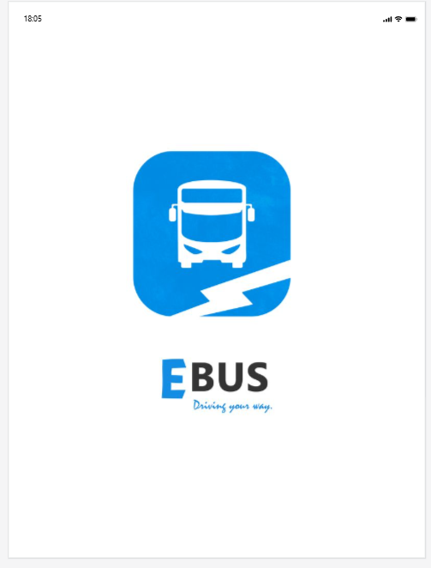

Screen 2: Loading / Processing Screen
Familiar Navigation Elements:
- Hamburger Menu (☰) – Top Left
  - Commonly used to open side navigation menu.
  - Recognized in most mobile applications.
- Home Icon – Top Right
  - Standard symbol for returning to home screen.
- Loading bar
  - Widely used to indicate background processing.
  - Assures users that the app is working.
- Mobile Status Bar
  - Displays time, battery, and signal strength.

Possibly Unfamiliar Elements:
- Empty Background with Only loading Bar
  - No progress percentage displayed.
  - Users may not know how long loading will take.
- No Text Indicator (e.g., “Loading… Please Wait”)
  - Lack of message may confuse some users.
- Home Icon Placement on Right Side
  - Some apps place it inside menu instead of header.
  - Might be slightly unfamiliar depending on user habits.

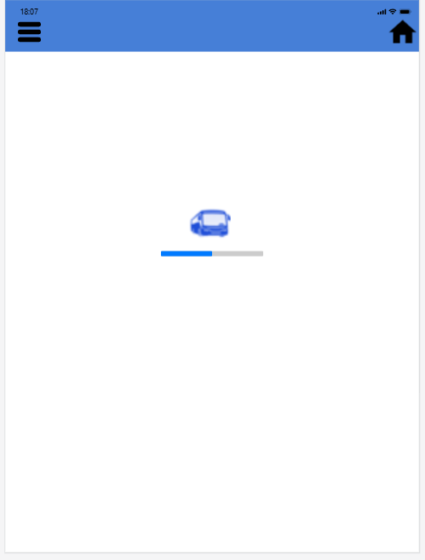
Screen 3: Train Search Page
Familiar Icons:
- Three-Dot Menu – Top Right
  - Represents additional options/settings.
- Calendar Navigation Arrows
  - Used to move between months.
- Highlighted Date
  - Indicates selected travel date.
Purpose:
- Collects travel details.
- Provides intuitive booking interface.

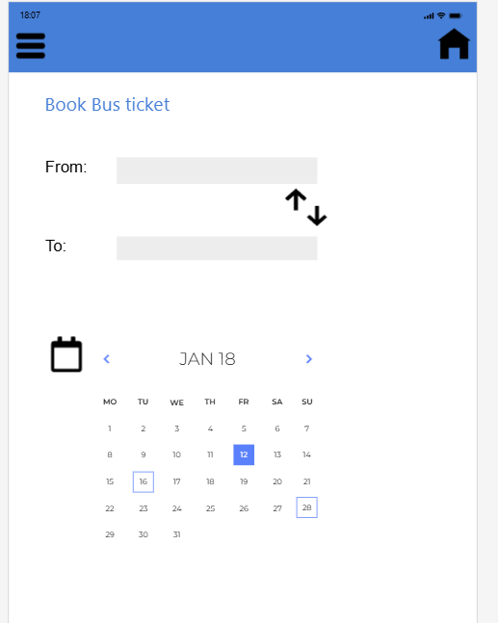
Screen 4: Train List Page
Familiar Icons:
- Back Arrow – Top Left
  - Returns to previous screen.
- Ratings
  - Shows Travel ratings
- Schedule Option
  - Shows detailed timing.
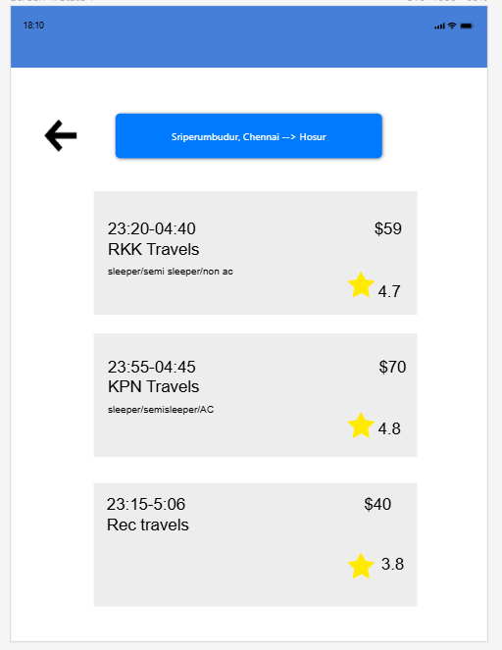
Screen 5: Payment Page
Unfamiliar Navigation Elements in Screen 6:
- QR Code as Primary Payment Method
  - Not all users may be familiar with scanning QR for payment.
  - Some users expect direct card input instead.
- Large Central QR Placement
  - Makes QR the main focus instead of “Pay Now” button.
  - May confuse users about next action.
- Wallet Number Display Without Clear Label
  - Users might not immediately understand whether it is account number or ID.
- Currency in Dollars ($) Instead of Local Currency
  - If used in Indian context, dollar display may confuse users.
- Multiple “Pay Now” Options
  - Having pay options beside each method may cause hesitation in choosing correct one.
Familiar Navigation Elements:
- Hamburger Menu (☰) – Top Left
  - Common icon for opening navigation drawer.
- Payment Icons (Wallet & Credit Card)
  - Universally recognized symbols for transaction methods.
- “Pay Now” Button
  - Standard Call-To-Action (CTA) for completing payment.
- Amount Display
  - Clearly shows
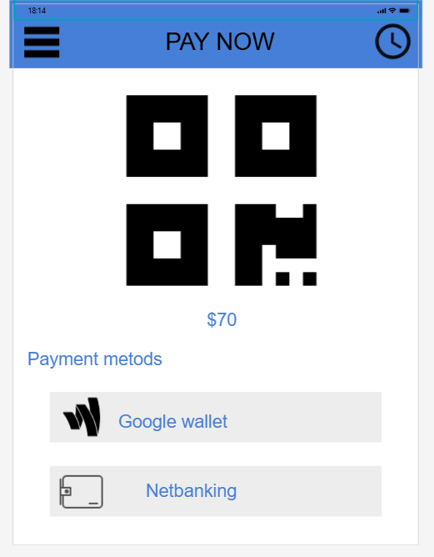
Screen 6: Payment Success Page
Description:
Confirms successful payment.
Familiar Elements:
- Tick (✔)
  - Universal symbol for success.
- Bold Amount Display
  - Confirms transaction value.
Purpose:
- Assures user that booking is successful.
- Provides ticket confirmation.
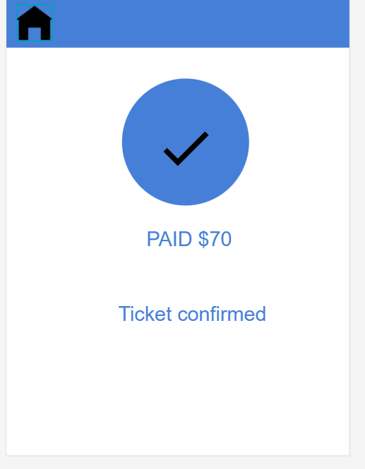

PROTOTYPE LINK: https://pr.to/AKMODV/

